Tasks To Be Performed:

1. Use the previous deployment

2. Create a service of type NodePort for NGINX deployment

3. Check the NodePort service on a browser to verify

**Procedure: -**

We need to create the nginx-service.yaml file

**apiVersion**: v1  
**kind**: Service  
**metadata**:  
 **name**: nginx-service  
**spec**:  
 **type**: NodePort  
 **selector**:  
 **app**: nginx  
 **ports**:  
 - **protocol**: TCP  
 **port**: 80  
 **targetPort**: 80  
 **nodePort**: 30007

sudo nano nginx-service.yaml  
 kubectl apply -f nginx-service.yaml  
 kubectl get services  
 kubectl get nodes -o wide  
 kubectl get svc nginx-service  
 sudo cat nginx-service  
 sudo cat nginx-service.yaml

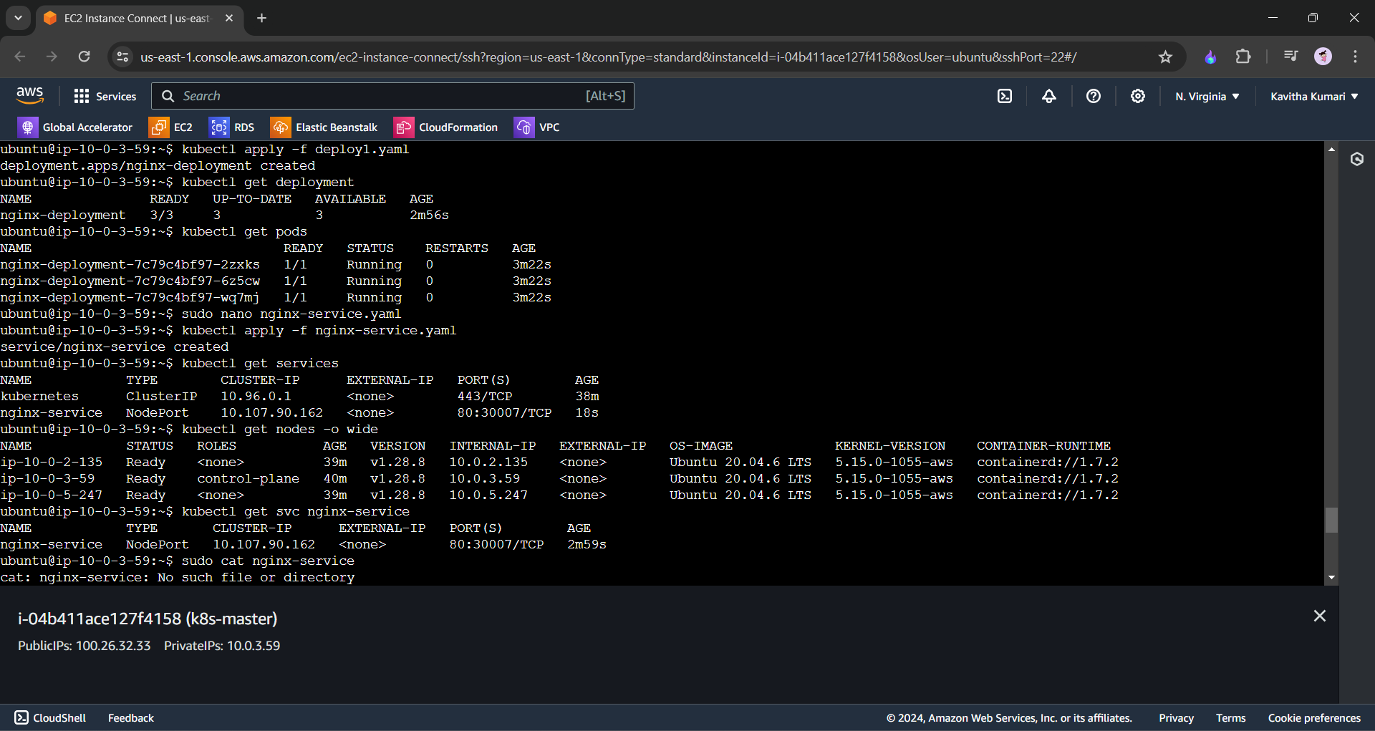

We can check the nginx server on the port <public-IP-of-master>:the port given in nodeport.

